I Can Hear

**Abstract**

The study explores the creation of a wearable device intended to interpret sign language gestures into spoken words and text. It utilizes an accelerometer and five flex sensors to capture arm and finger movements. By analyzing data from these sensors, the device identifies specific gestures corresponding to letters in American Sign Language (ASL). Through a mobile application, these gestures are then translated into audible speech and written text. Early trials suggest that the device can swiftly translate sign language gestures into speech and text, taking an average of 0.6 seconds. Overall, the project achieves the potential to facilitate communication for individuals who rely on sign language, offering real-time translation capabilities.

**Introduction**

Humans have long relied on sign languages, particularly within deaf cultures, as a means of communication and conveying messages. These languages involve the use of hand shapes, orientations, movements, and facial expressions simultaneously. However, the general populace is often unfamiliar with sign language, posing challenges for those who rely on it as their primary form of communication. To address this issue, advancements in technology have led to the development of tools that enable deaf communities to communicate with others. These include various types of hearing aids, such as behind-the-ear, in-the-ear, and canal aids. While these aids are helpful, they can sometimes be uncomfortable to wear and may amplify background noise.

As a solution, scientists have been exploring techniques to translate sign language gestures, with wearable technology and vision-based systems emerging as the main approaches. Vision-based systems utilize image processing techniques to analyze hand and finger movements. Several studies have investigated the use of vision-based systems for sign language translation.

Wearable devices, coupled with microcontrollers to eliminate cords, are being developed to interpret sign language into written or spoken words. In this project, Bluetooth-enabled mobile phones are used to display translated text and audio. It also focuses on translating the American Sign Language alphabet. The primary objective is to create a wearable device that facilitates communication between deaf communities and the general public, prioritizing user comfort.

**Hardware components**

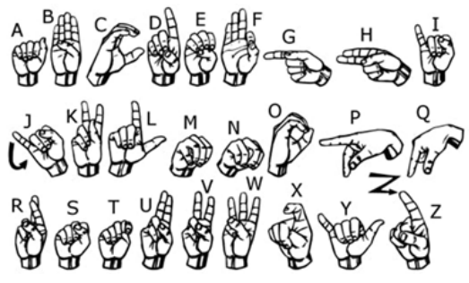A smart glove was designed to translate ASL characters into both written and spoken formats via a mobile phone application. The glove incorporated five flex sensors, one for each finger, to detect finger bending, along with an accelerometer located on the back of the hand to discern hand orientation (horizontal or vertical). An Arduino Nano microcontroller was employed for coding purposes, while an HC-05 Bluetooth module facilitated connectivity between the glove and the mobile phone.

**Figure 1** American Sign Language Alphabetic representation.

Flex sensor

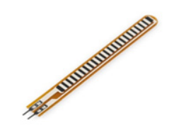A flex sensor, in fig 2.1 is a type of sensor that measures deflection or bending by utilizing materials like plastic and carbon. When the plastic strip holding the carbon surface is bent, the sensor's resistance changes accordingly. This property earns it the nickname "bend sensor." There are two main sizes of flex sensors: 2.2-inch and 4.5-inch variants, each with its own resistance characteristics. In this project, 2.2-inch flex sensors were utilized. These sensors have diverse applications, including computer interfaces, rehabilitation, servo motor control, security systems, music interfaces, and intensity control.

**Figure 2**

Flex sensors are two-terminal devices without polarized terminals, such as capacitors or diodes, meaning they lack positive or negative terminals. They require a power supply of 3.3V to 5V DC, which can be sourced from any suitable interface. Flex sensors are commonly used in situations where measuring the degree of bending, flexing, or change in angle of a device or instrument is necessary. The sensor's internal resistance changes in a roughly linear manner with the flex angle, allowing the flex angle to be determined within electrical parameter resistances by attaching the sensor to the apparatus.

In this project, one flex sensor was allocated to each finger. Each flex sensor was connected to the Arduino analog pin and to 5V through a 10kΩ resistance, with one pin connected to GND. The minimum and maximum values of each flex sensor were calibrated according to the degree of finger bending. By employing appropriate code, the values were represented as a range of angles from 0 to 90 degrees. Finally, each letter of the American Sign Language alphabet was encoded in the code using the appropriate combination of finger degrees.

**Accelerometer ADXL335**

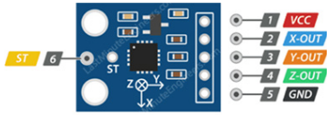Accelerometers are commonly used in a variety of applications where detecting motion and tilt is necessary without consuming much power or being expensive. These applications range from mobile devices to gaming systems, disk drive protection, image stabilization, and sports and fitness equipment. At the heart of an accelerometer lies a silicon wafer, supported by polysilicon springs, forming a micro-machined MEMS structure. When acceleration occurs along the X, Y, or Z axes, this structure deflects, changing the capacitance between fixed and suspended plates. This capacitance change is then translated into an analog output voltage, with the ADXL335 module being a prime example. It features a small, low-power, low-noise triple-axis MEMS accelerometer capable of measuring both static and dynamic acceleration caused by motion, shock, or vibration.

**Figure 3** ADXL335 accelerometer pinout.

**Bluetooth module HC-05**

The HC-05 Bluetooth Module, depicted in Figure 4, is designed to establish wireless serial connections seamlessly. It communicates via serial transmission, simplifying interaction with controllers or PCs. Operating in two modes, it allows users to modify default settings in AT 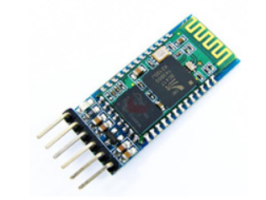Command mode and exchange data with other Bluetooth devices in Data mode. By utilizing the key pin, users can switch between these modes as required. In this setup, the module facilitated communication between an application and the Arduino, enabling the transmission of specified letters from the Arduino to the phone.

**Figure 4** Bluetooth HC05 module.

**Arduino nano**

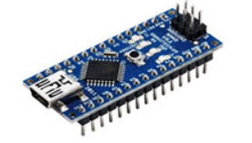The Nano, known as the smallest and most traditional breadboard-friendly Arduino board, is showcased in Figure 5. It comes with a Mini-B USB connector and pin headers, making it easy to connect to a breadboard. Its compact size led to its selection for use in this project. The Arduino IDE was utilized to upload code to the Nano, which was then connected to various components including flex sensors, an accelerometer, digital pins, contact sensors, and a Bluetooth module.

**Figure 5** Arduino nano.

**The prototype**

